

CAPSTONE PROJECT REPORT
Report 1 – Project Introduction

– Ho Chi Minh, October 2026 –
Table of Contents
I. Record of Changes 3
II. Project Introduction 4
1. Overview 4
1.1 Project Information 4
1.2 Project Team 4
2. Product Background 4
3. Existing Systems 4
3.1 System name1 4
3.2 System name2 4
4. Business Opportunity 4
5. Software Product Vision 5
6. Project Scope & Limitations 5
6.1 Major Features 5
6.2 Limitations & Exclusions 6

I. Record of Changes
Date | A*  M, D | In charge | Change Description
28/10/2026 | A | Nguyễn Mạnh Lực | Added project information, team, product background, product vision, existing systems and business opportunity
29/10/2026 | A | Nguyễb Mạnh Lực | Added major features (FE-01 to FE-19), feature map, and limitations
*A - Added M - Modified D - Deleted

II. Project Introduction

1. Overview

1.1 Project Information
- Project name: CodeSwitchLabel: Speech Data Collection and Quality Control System
- Project code: FA26SE303
- Group name: GFA26SE193
- Software type: Web

1.2 Project Team
Full Name | Role | Email | Mobile
Trương Thị Mỹ Ngọc | Lecturer | ngocttm4@fpt.edu.vn
Nguyễn Mạnh Lực | Leader | LucNMSE141086@fpt.edu.vn | 0392645487
Nguyễn Quang Hải | Member | HaiNQSE171707@fpt.edu.vn | 0918654485
Hồ Lê Nhật Khánh | Member | KhanhHLNSE161401@fpt.edu.vn | 0365953205
Đặng Đinh Thiên Lân | Member | LanDDTSE171568@fpt.edu.vn | 0934930041

2. Product Background
Current speech-to-text systems generally achieve high accuracy; however, their performance decreases when speech contains code-switching or mixed-language content. For example, in a Vietnamese utterance such as “Em nhớ upload tài liệu trước deadline nhé”, the presence of English words can reduce ASR performance. The purpose of this project is to develop a system for collecting speech utterances containing Vietnamese-English code-switching as a foundation for improving ASR models.
Raw code-switched speech recordings are useful for ASR model training only when they are accurately transcribed at the word level, with each word assigned a language label (Vietnamese/English), segmented into utterances, and time-aligned with the audio.
Manual transcription of code-switched speech is substantially more difficult than monolingual transcription: annotators must determine language boundaries at the word level, handle Vietnamese-accented pronunciations of English loanwords and phonetic borrowings, and identify code-switch points that do not necessarily align with punctuation, while maintaining consistent transcription conventions across a large number of annotators.
Without a dedicated annotation system and quality-control workflow, transcription is slow, inconsistent across annotators, and produces a corpus with unreliable labels, directly limiting the accuracy of ASR models trained on the resulting data.

3. Existing Systems

3.1 Mozilla Common Voice
- Mozilla Common Voice – an open-source, crowdsourced platform where volunteers record and validate speech to build public voice datasets for many languages, including Vietnamese.
- Link: https://commonvoice.mozilla.org
- Actor: Guest, Speaker, Reviewer, Admin

No. | Feature | Description
1 | Login and Registration | Guests register or log in to become Speakers or Reviewers and track their contributions.
2 | Record Sentences | Speakers read a displayed sentence aloud and record it in the browser.
3 | Listen and Re-record | Speakers play back their recording and re-record before submitting.
4 | Validate Recordings | Speakers submit new sentences to be added to the text corpus.
5 | Contribute Sentences | Speakers submit new sentences to be added to the text corpus.
6 | Review Sentences | Reviewers review submitted sentences before they are used for recording.
7 | View Statistics | Guests, Speakers and Reviewers view contribution statistics and progress for each language.
8 | Download Dataset | Admins manage sentence and recording data and publish the speech dataset for download.

3.2 Label Studio
- Label Studio – an open-source data labeling tool by HumanSignal that supports audio transcription and labeling for building machine learning datasets.
-Link: https://labelstud.io/
-Actor: Admin, Manager, Annotator, Reviewer

No. | Feature | Description
1 | Login and Registration | Annotators, Reviewers and Managers log in or register for an account in a workspace.
2 | Create Project | Managers create a labeling project and configure the labeling interface.
3 | Import Data | Managers import audio files and related data into a project.
4 | Transcribe Audio | Annotators listen to audio and type the transcription.
5 | Label Audio Segments | Annotators select time segments on the waveform and assign labels (e.g., Vietnamese/English).
6 | Review Annotations | Reviewers accept or reject annotations made by Annotators.
7 | Manage Members | Admins invite members and assign roles and projects to them.
8 | Export Dataset | Admins manage sentence and recording data and publish the speech dataset for download.

4. Business Opportunity

Problems Identified:
- ASR systems perform well on monolingual speech, but their accuracy drops on Vietnamese–English code-switched speech, which is common in everyday Vietnamese communication.
- Reliable code-switched speech data for training ASR models is limited, and collecting it manually is slow, inconsistent across annotators and produces unreliable labels.
- Reviewing recordings is the most time-consuming step: every recording must be listened to by several human reviewers, which creates a heavy workload and slows down dataset creation.
- Existing tools only partly meet this need: crowdsourcing platforms (e.g., Mozilla Common Voice) are designed for monolingual sentences with simple Yes/No validation, and annotation tools (e.g., Label Studio) cannot record speech and offer advanced review mainly in paid editions.
- There is no tool that combines recording, quality control, and task, target and deadline management for code-switched speech data.

Proposed Solution:
- Deliver a web-based system that manages the full workflow of Vietnamese–English code-switched speech data: reviewing and contributing text, recording speech, reviewing recordings and managing the dataset.
- Apply automatic quality checks and a multi-stage review process with clear rejection reasons to keep the data consistent.
- Integrate an AI reviewer that acts as an additional reviewer: it transcribes each recording with a speech-to-text (ASR) model and compares the transcript with the sentence the Speaker was asked to read, then gives a review result that is counted together with the human reviewers’ decisions.
- Enable Task Managers to assign tasks, set targets and deadlines, and monitor the progress of Speakers and Reviewers, and enable Admins to manage data, users, statistics and quality settings.
Value Proposition:
CodeSwitchLabel reduces data-processing effort, lowers the workload of human reviewers through AI-assisted review, improves consistency across contributors and increases the reliability of the speech corpus, providing high-quality Vietnamese–English code-switched speech data as a foundation for improving ASR models.

5. Software Product Vision
For research teams and organisations that need high-quality Vietnamese–English code-switched speech data to improve Automatic Speech Recognition (ASR) models, CodeSwitchLabel is a web-based system that manages the full data workflow, from reviewing and contributing text, recording speech and checking audio quality, to multi-stage human and AI-assisted review and dataset management. Unlike general crowdsourcing platforms or annotation tools, CodeSwitchLabel is designed specifically for code-switched sentence pairs, combines automatic quality checks with an AI reviewer to reduce the workload of human reviewers, and gives managers full control over tasks, targets, deadlines and progress. As a result, speech corpora can be built faster, more consistently and with more reliable labels.

6. Project Scope & Limitations
6.1 Scope
- Speaker:
  - Review Text: Check whether a provided sentence is meaningful, natural, and suitable for recording; reject or edit the sentence before recording if necessary.
  - Record Speech: Read and record the sentence; listen to the recording and re-record it when necessary.
  - Contribute Text: Contribute new sentences that meet the system requirements.
  - View History: View recording history (review rounds, status, result, and rejection reasons) and contribution history.
- Reviewer:
  - Receive Review Task: Receive tasks from the Task Manager or Admin, including the recording list, Review Target, and deadline.
  - Review Recordings: Listen to and review recordings by Speaker or through random selection.
  - Approve/Reject Recordings: Approve recordings that meet the requirements or reject recordings with any content, audio-quality, or pronunciation issue.
  - Record Rejection Reason: Record the specific reason for rejecting each recording.
  - AI-Assisted Review: An AI Reviewer converts each recording to text using a speech-to-text model, compares it with the sentence the Speaker read, and acts as an additional reviewer to reduce the workload of human Reviewers.
  - Track Review Progress: Track the number of reviewed recordings, Review Target, progress, and remaining time to the deadline.
  - View Review History: View the history of reviewed recordings and contributed sentences.
- Task Manager:
  - Create Tasks: Create tasks for Speakers and Reviewers.
  - Assign Tasks: Assign tasks to individual Speakers and Reviewers.
  - Set Target & Deadline: Set the required workload and completion deadline for each task.
  - Monitor Progress: Monitor the progress of each Speaker and Reviewer.
  - Reassign Tasks: Reallocate tasks when necessary.
- Admin:
  - Manage Text Data: Import, add, edit, and manage the text corpus.
  - Manage Users & Roles: Manage accounts, user information, and access permissions for system actors.
  - Manage Recordings & Dataset: View, search, filter, manage, and download speech recordings and datasets.
  - View Dashboard & Statistics: Monitor the total number of sentences, total recording duration, Approved/Rejected recordings, number of Speakers and Reviewers, and overall data status.
  - Monitor Data Quality: Monitor common rejection reasons, approval rates, and recording quality for each Speaker.
  - System Configuration: Configure review criteria, quality requirements, and general system settings

6.1 Major Features
FE-01: Review provided script for quality, report script errors, and propose script edits before recording (Speaker).
FE-02: Record code-switched and Vietnamese script pairs, listen back and re-record, pass an automatic quality check, and re-record rejected pairs (Speaker).
FE-03: Contribute new script pairs and tag the English words in each script (Speaker).
FE-04: View recording history and contribution history (Speaker).
FE-05: Receive review tasks with the task list, target, and deadline (Reviewer).
FE-06: Review recordings by script pair, approving them or rejecting them with specific reasons and comments (Reviewer).
FE-07: AI-assisted review: the AI Reviewer converts each recording to text, compares it with the given script, and gives an approve or reject result to reduce the workload of human Reviewers.
FE-08: Review scripts contributed by Speakers and resolve script edit proposals (Reviewer).
FE-09: View the history of reviewed recordings, contributions, and proposals (Reviewer).
FE-10: Create, edit, and delete recording waves with a topic, target, and time period (Task Manager).
FE-11: Create recording tasks for Speakers and review tasks for Reviewers, and attach them to a recording wave (Task Manager).
FE-12: Assign Speakers and Reviewers to tasks, and set the task target and the target for each user (Task Manager).
FE-13: Monitor wave progress and task statistics by role, and search and filter tasks by status (Task Manager).
FE-14: Edit tasks, add or remove assignees, change task status, and remove tasks from a wave (Task Manager).
FE-15: View the dashboard and statistics, including users by role, total recording duration, approval/rejection/pending rates, and common rejection reasons (Admin).
FE-16: Create users, assign roles, search and filter users by role, and delete users (Admin).
FE-17: Add, edit, import (JSON), search, filter, and delete scripts in the text corpus (Admin).
FE-18: Search and filter recordings, view review feedback, and create, release, and download datasets (.ZIP) (Admin).
FE-19: Configure topics and the maximum number of English words allowed per script (Admin).
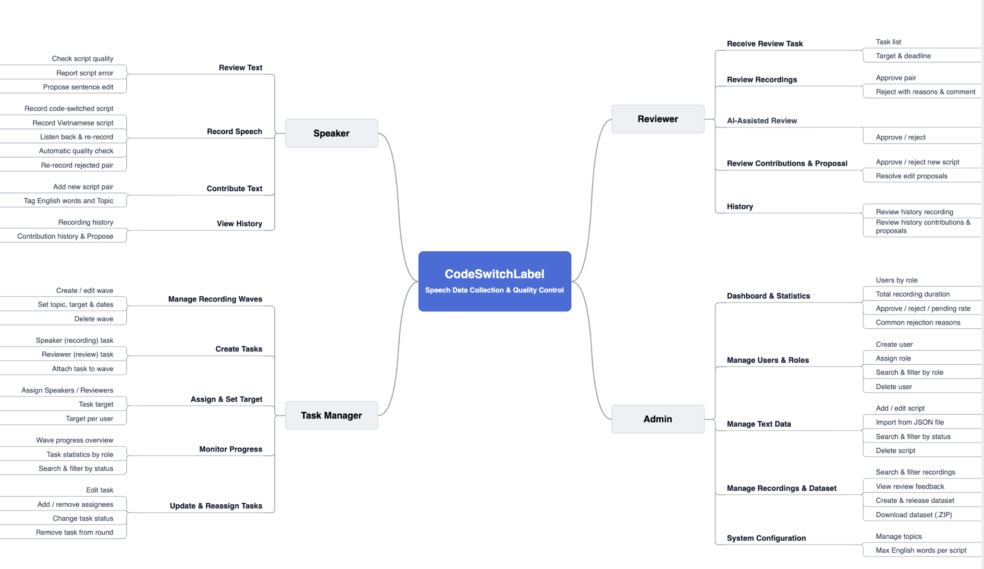

6.2 Limitations & Exclusions
LI-1: The system supports only Vietnamese–English code-switched speech; other language pairs are not included.

LI-2: The AI Reviewer supports but does not replace human Reviewers; its accuracy depends on the selected speech-to-text model.

